|  |  |
| --- | --- |
| EX.NO:-2 | **Water Jug Problem using BFS** |
| DATE: |

**Program:**

from collections import deque

def BFS(a, b, target):

m = {}

isSolvable = False

path = []

q = deque()

q.append((0, 0))

while (len(q) > 0):

u = q.popleft()

if ((u[0], u[1]) in m):

continue

if ((u[0] > a or u[1] > b or

u[0] < 0 or u[1] < 0)):

continue

path.append([u[0], u[1]])

m[(u[0], u[1])] = 1

if (u[0] == target or u[1] == target):

isSolvable = True

if (u[0] == target):

if (u[1] != 0):

path.append([u[0], 0])

else:

if (u[0] != 0):

path.append([0, u[1]])

sz = len(path)

for i in range(sz):

print("(", path[i][0], ",",

path[i][1], ")")

break

q.append([u[0], b])

q.append([a, u[1]])

for ap in range(max(a, b) + 1):

c = u[0] + ap

d = u[1] - ap

if (c == a or (d == 0 and d >= 0)):

q.append([c, d])

c = u[0] - ap

d = u[1] + ap

if ((c == 0 and c >= 0) or d == b):

q.append([c, d])

q.append([a, 0])

q.append([0, b])

if (not isSolvable):

print("No solution")

if __name__ == '__main__':

Jug1, Jug2, target = 4, 3, 2

print("Path from initial state "

"to solution state ::")

BFS(Jug1, Jug2, target)

**Output:**

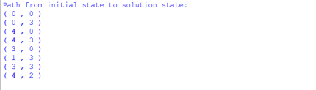

**RESULT:**

The given Water jug using BFS program is Successful compiled and implemented.